OUTPUT SCREENSHOTS OF PHASE 2 END PROJECT RAILWAY CROSSING STATUS

Admin Login Email : Subham@roy

Admin Login Password : 123

# * ADMIN END

* Home Page of the application **Railway Crossing Status :**

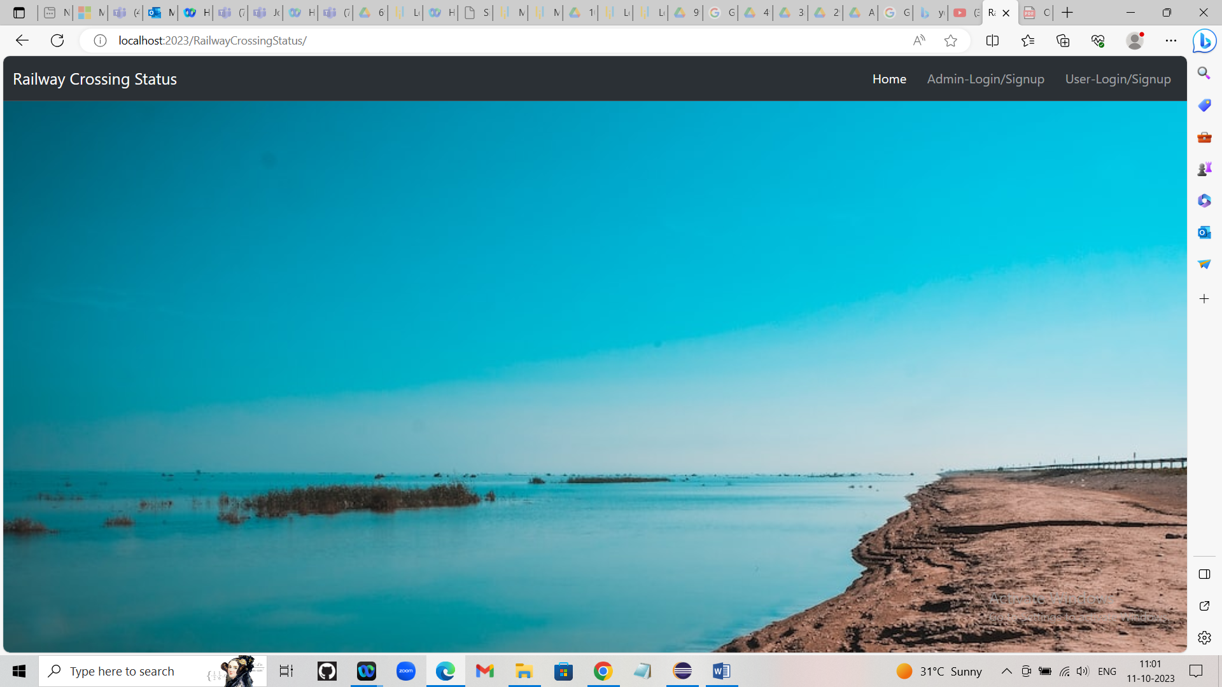

* **Click on Admin-Login (If You are Admin). It will redirect to Admin Home Page :** 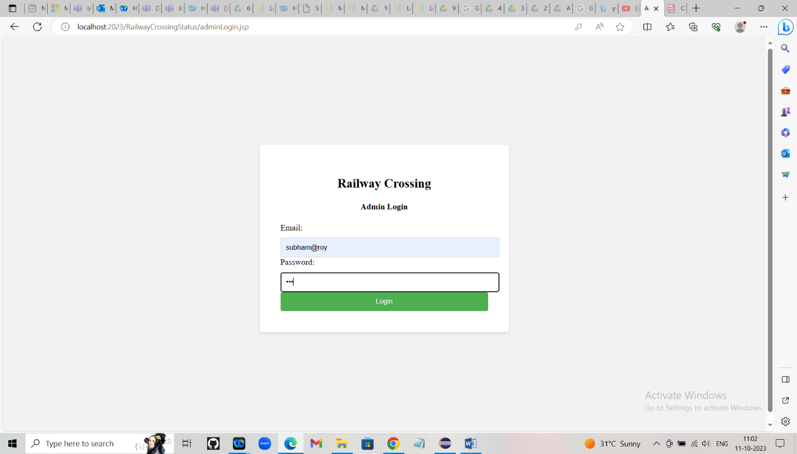
* **After clicking Login button it will redirect to the admin home page :**

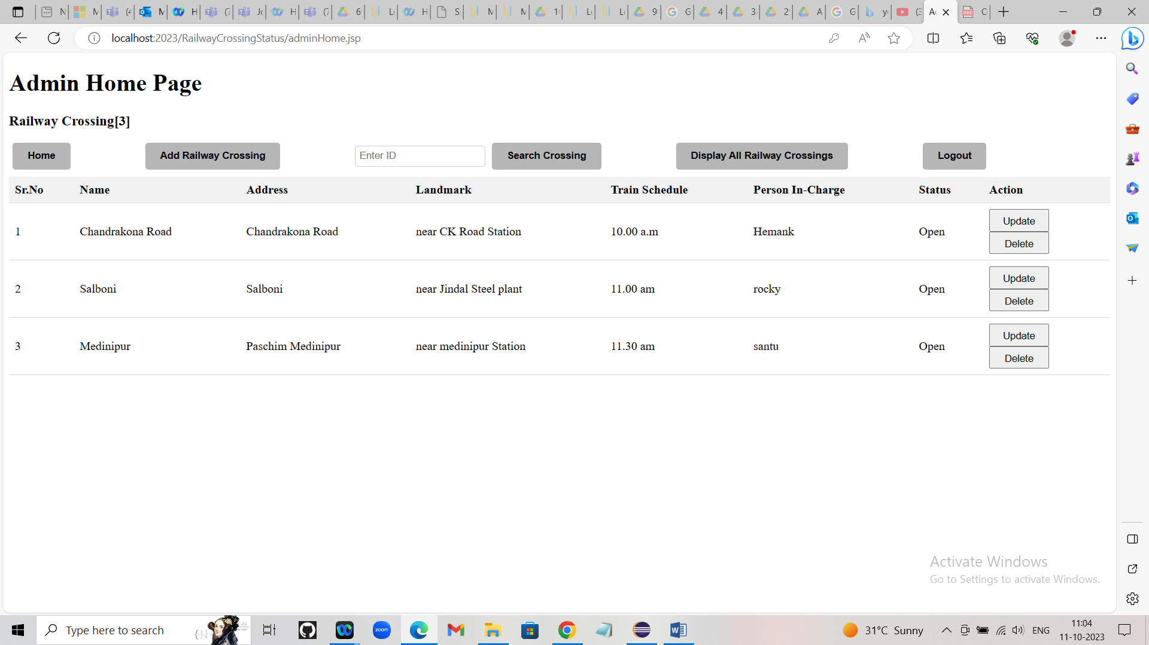

* **Comparing it with database :**
* 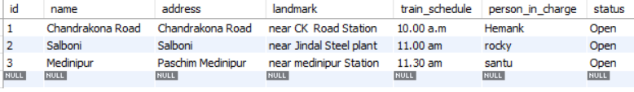
* **Add a new rail way crossing by clicking Add Railway Crossing :**

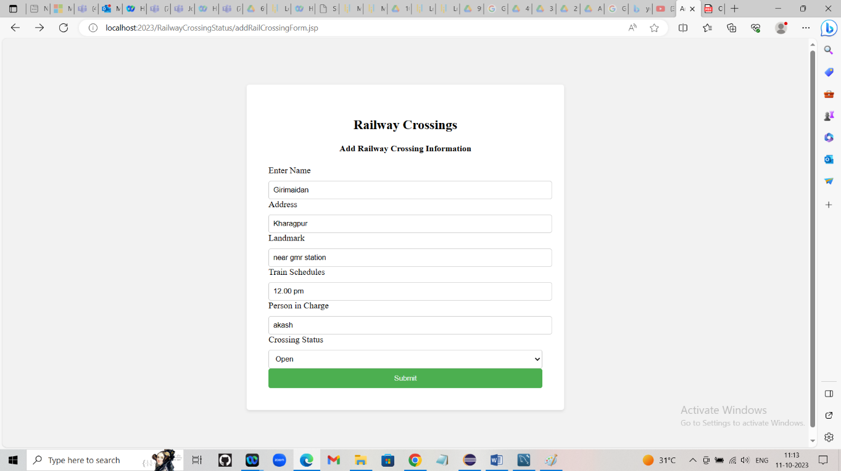

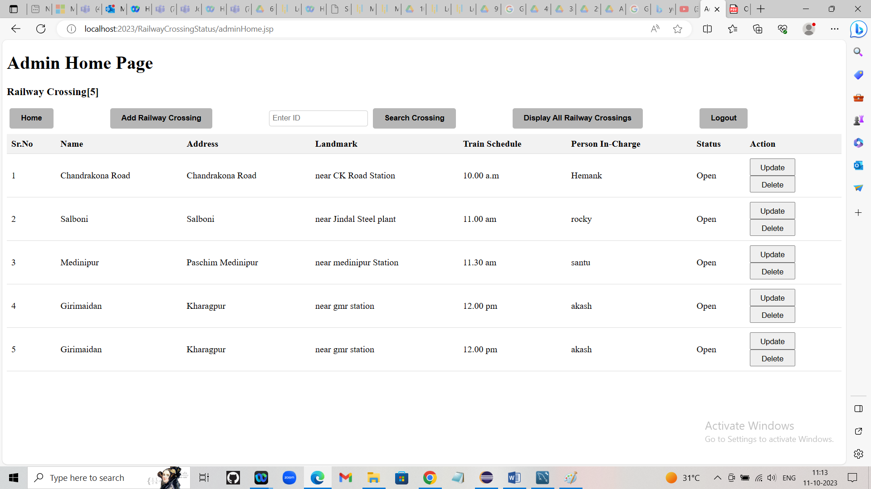



Update a railway crossing by clicking Update button :

**Before Update :**



* **After Update :**

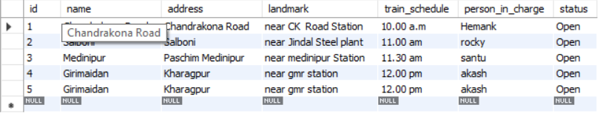

* **Delete a railway Crossing :**
* **Before Delete :**



* **After Delete :**

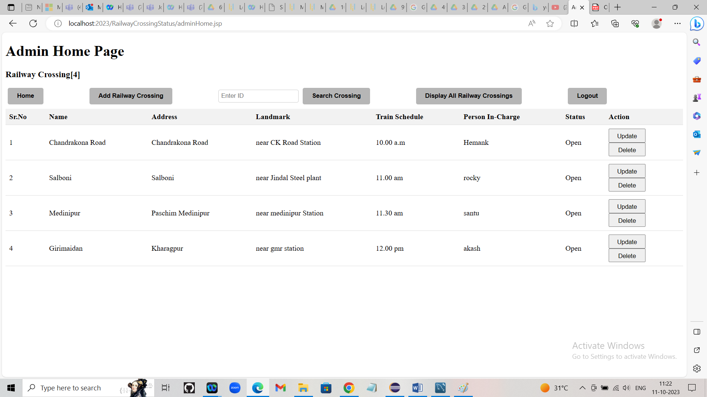

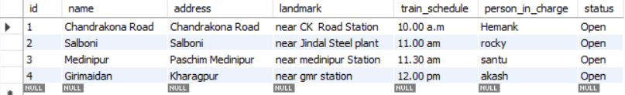

* **Search a railway crossing by its id by clicking the Search Crossing and entering Sr.No :**

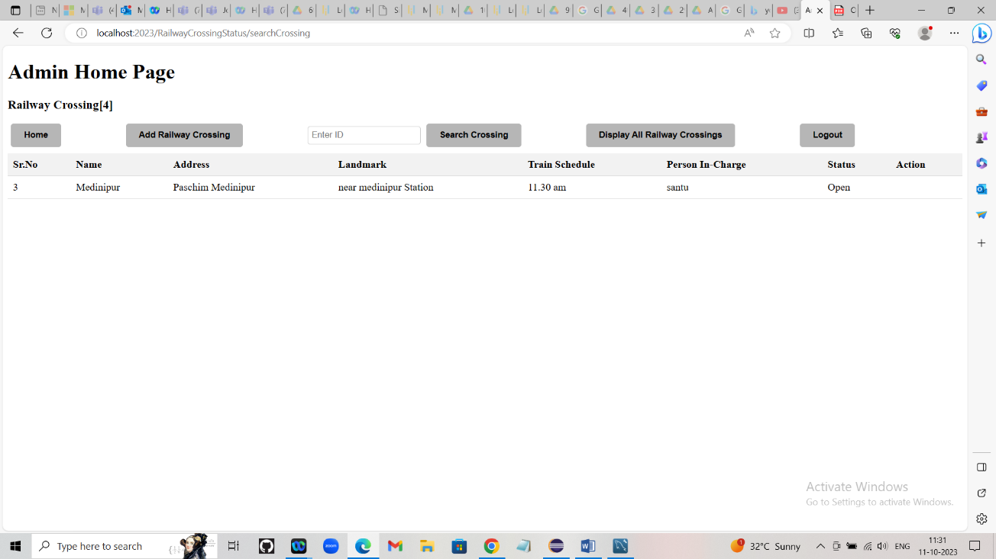

* **Display all Railway crossings by clicking Display All Railway Crossings :**

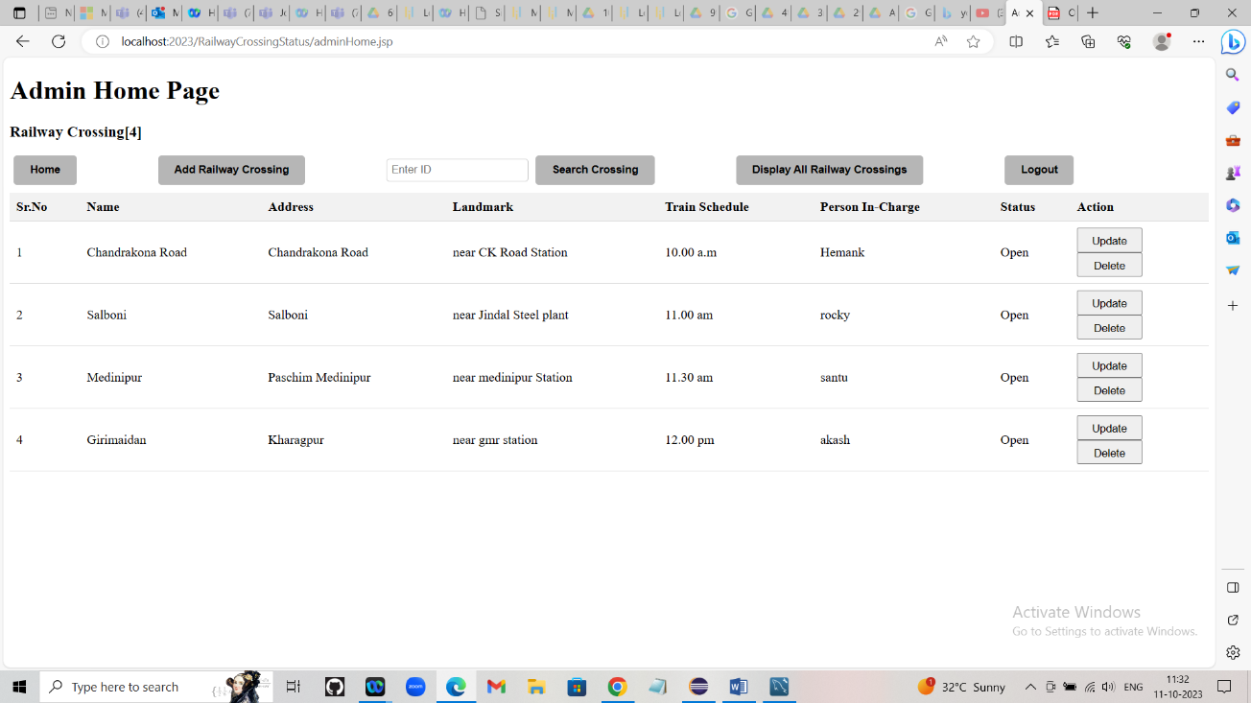

* **Clicking Logout the admin will be logged out from the page to the login page :**
* **Clicking Home page will redirect the admin to the application Home page :**

# * USER END

For users they needs to register their details and their details will be stored in the database :



Click on User-Login/Signup (This page will redirect the user to login page) :

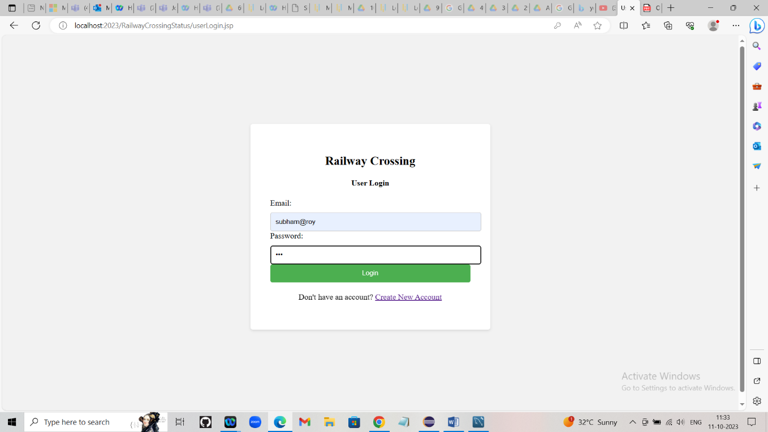

* **If the user don’t have any account they needs to click on the Create New Account button, It will redirect the user to the signup page :**

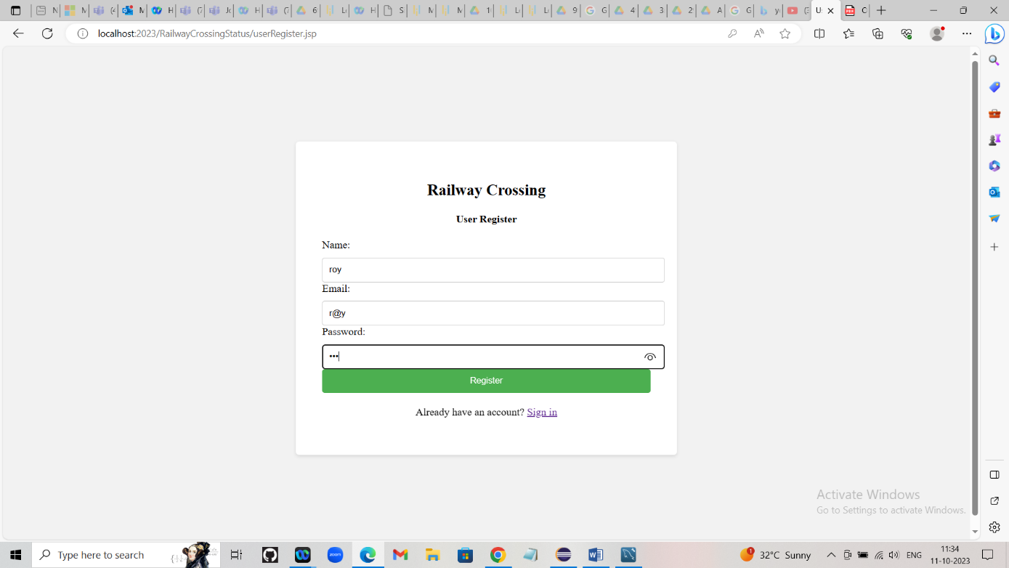

* **After hitting register the user account will be created and its value will be stored in the database and the page will redirect to the login page :**

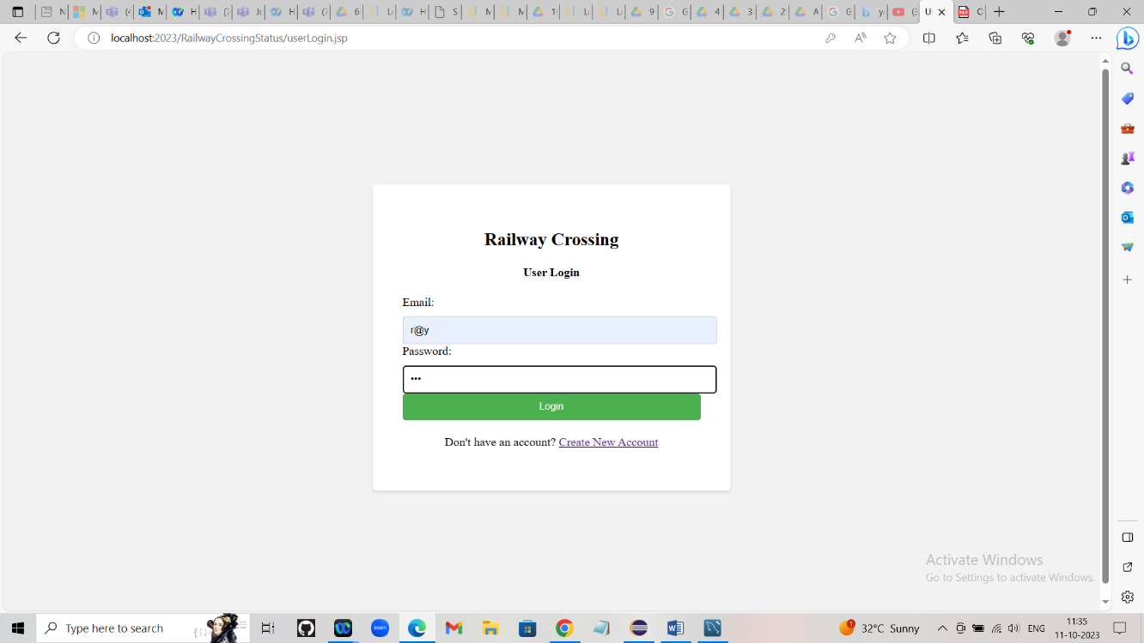

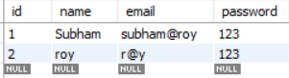

* **If the authentication is successful the user will redirect to the user home page otherwise it will redirect to the login page again :**

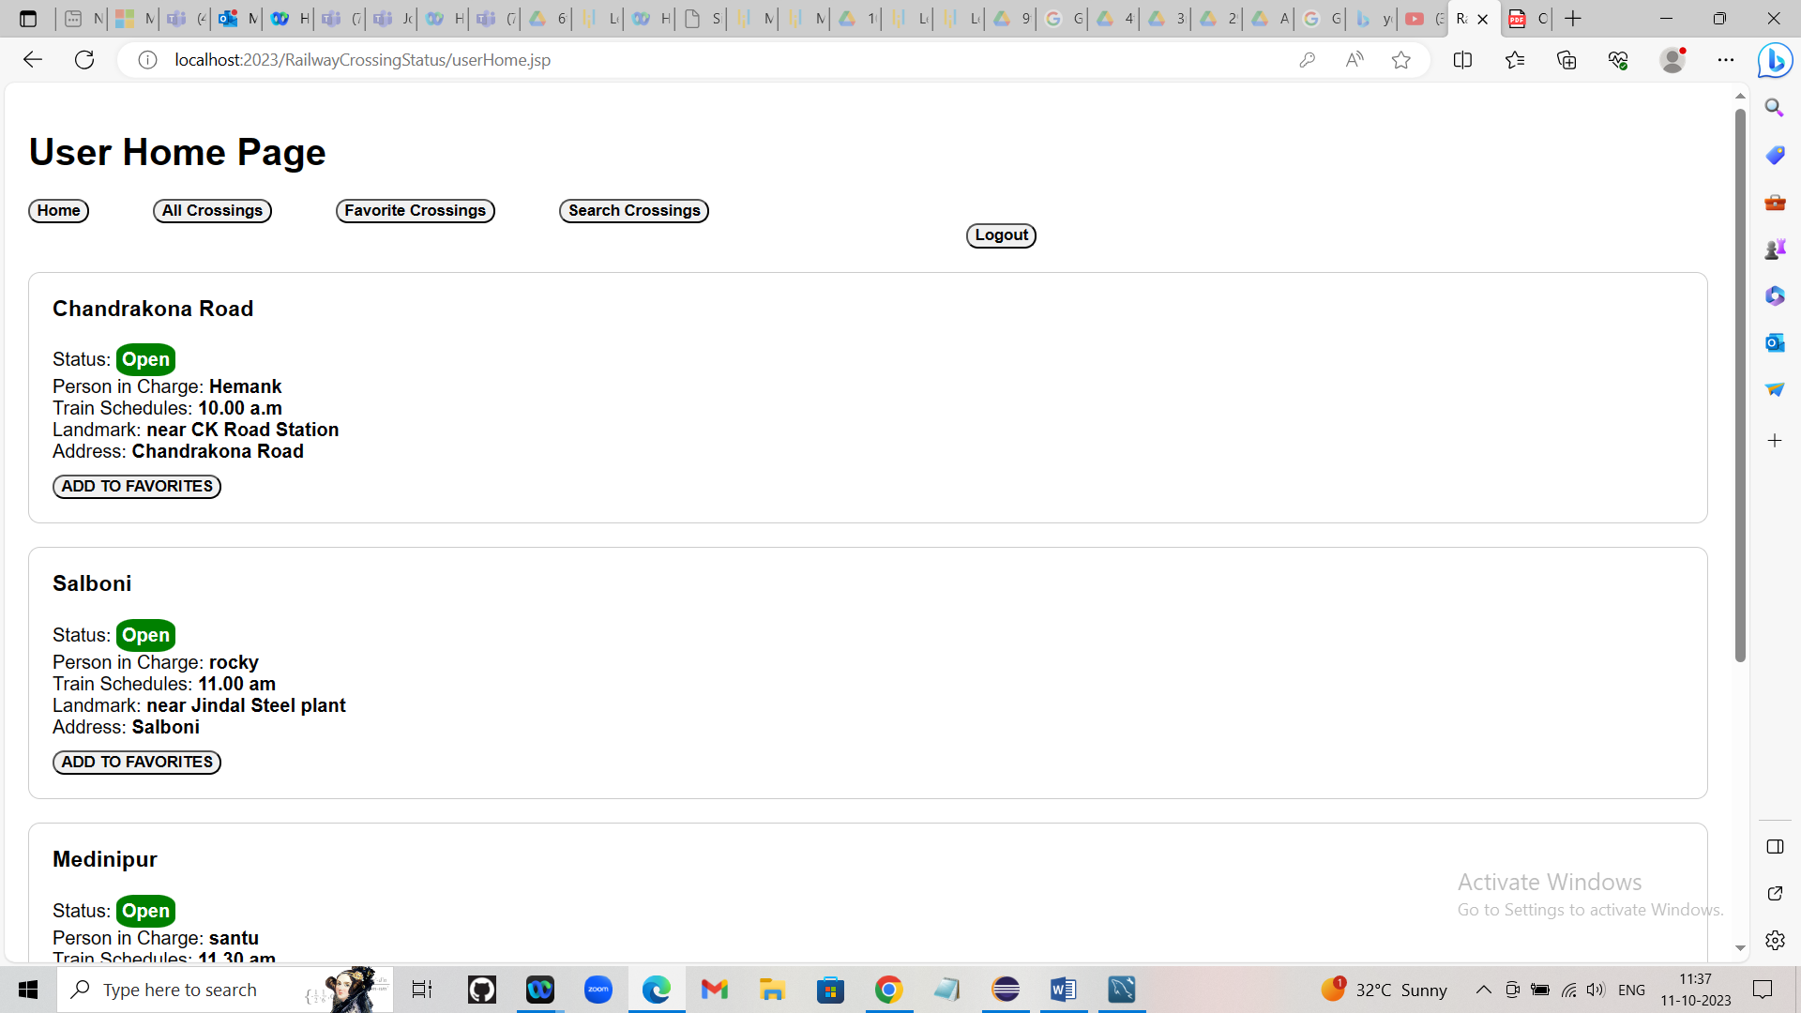

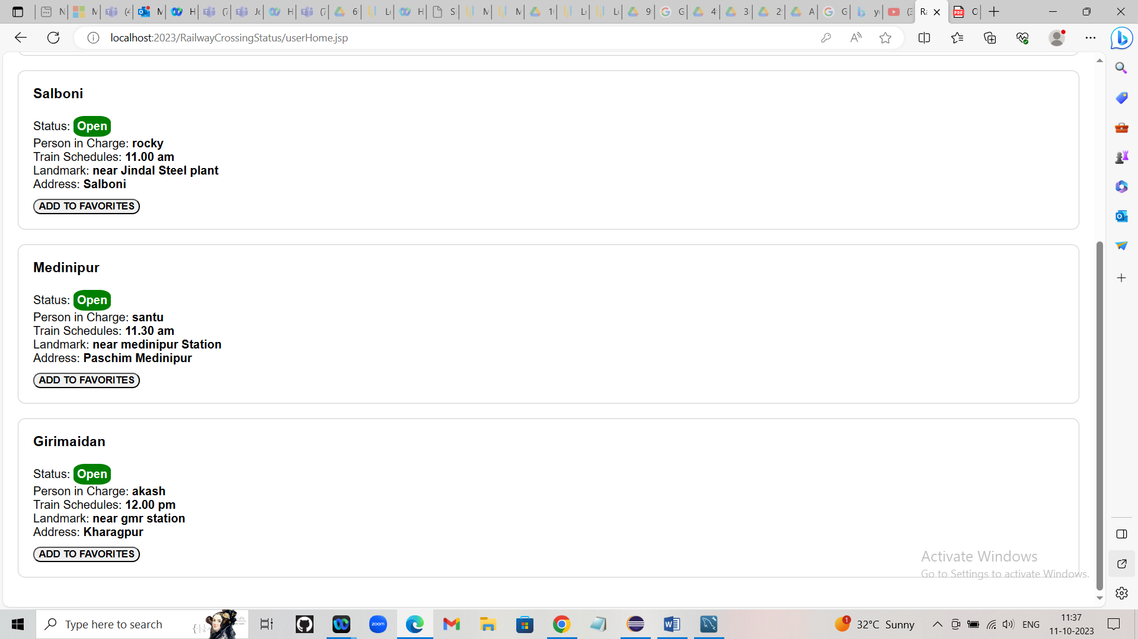

* **If the user wants to add any crossings as his/her favourites, then**

he/she can add it by clicking ADD TO FAVORITES button and favourite crossings can be displayed by using Favorite Crossings button :

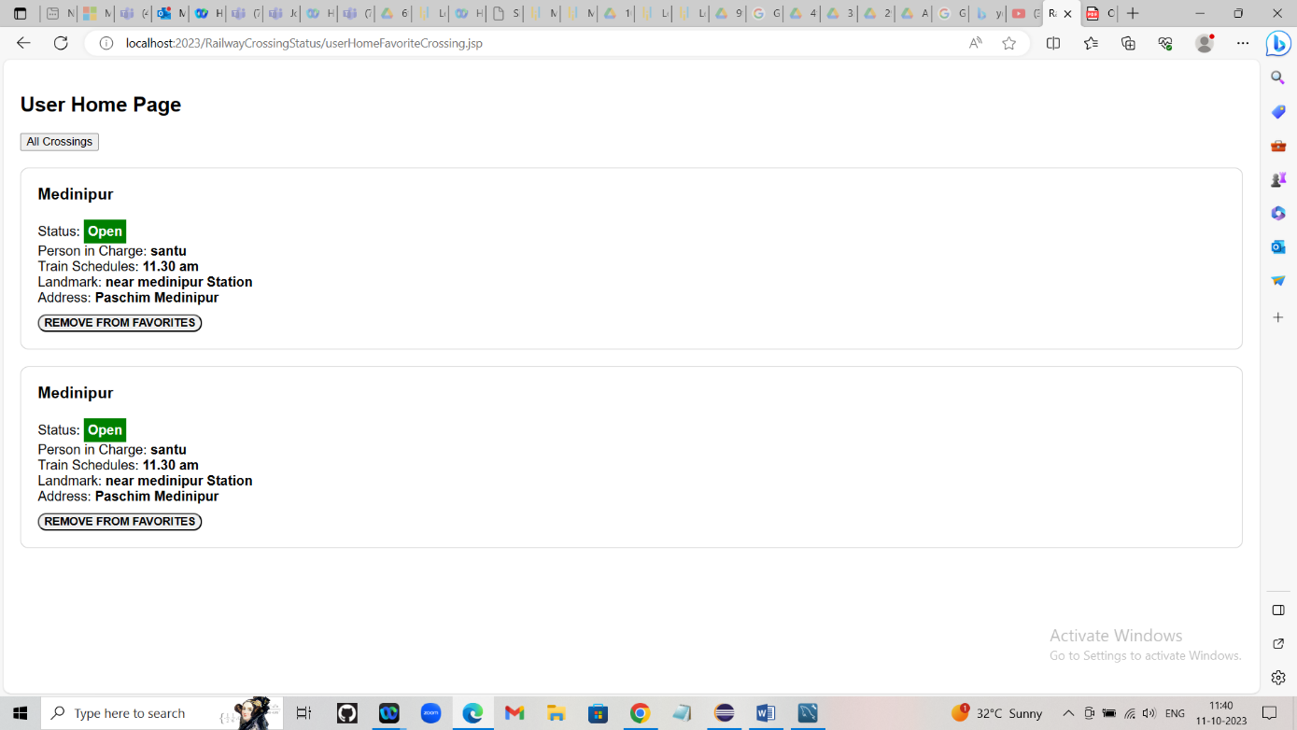

* **If the user wants to remove any crossings from his/her favourites, then he/she can remove it by clicking REMOVE FROM FAVORITES button :**

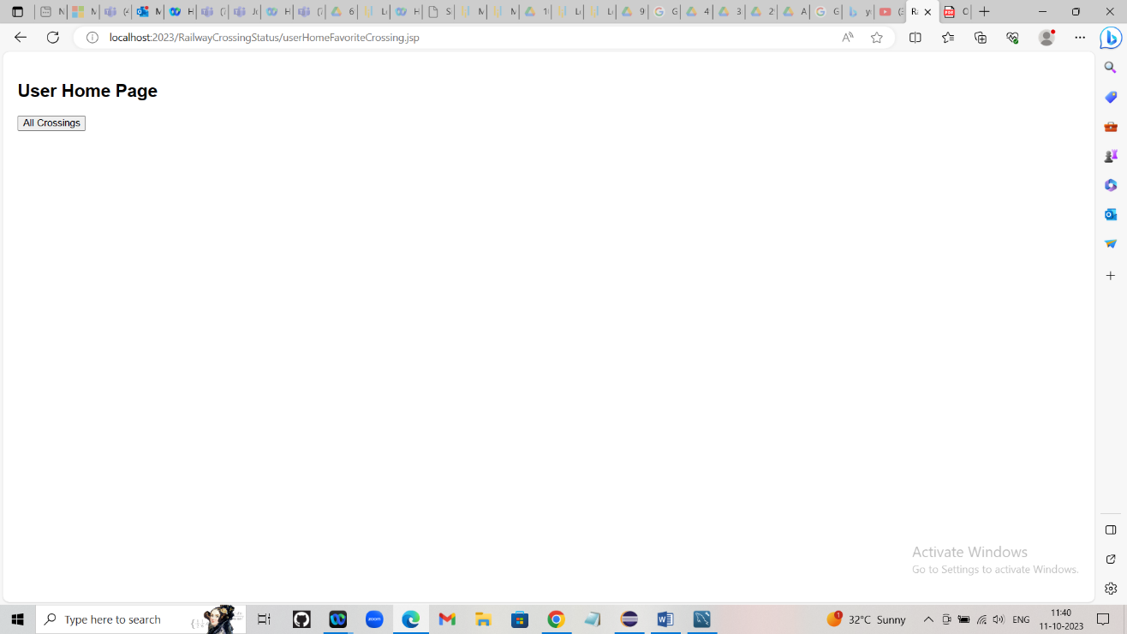

By clicking All Crossing the user will redirect to the user home page which contains all railway crossing details :

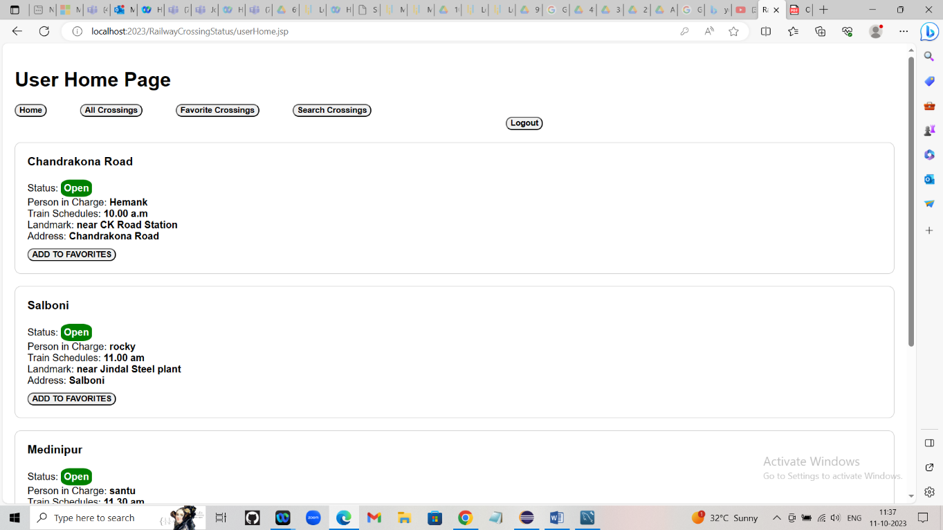

* **User can search crossing list by using Search Crossings button :**

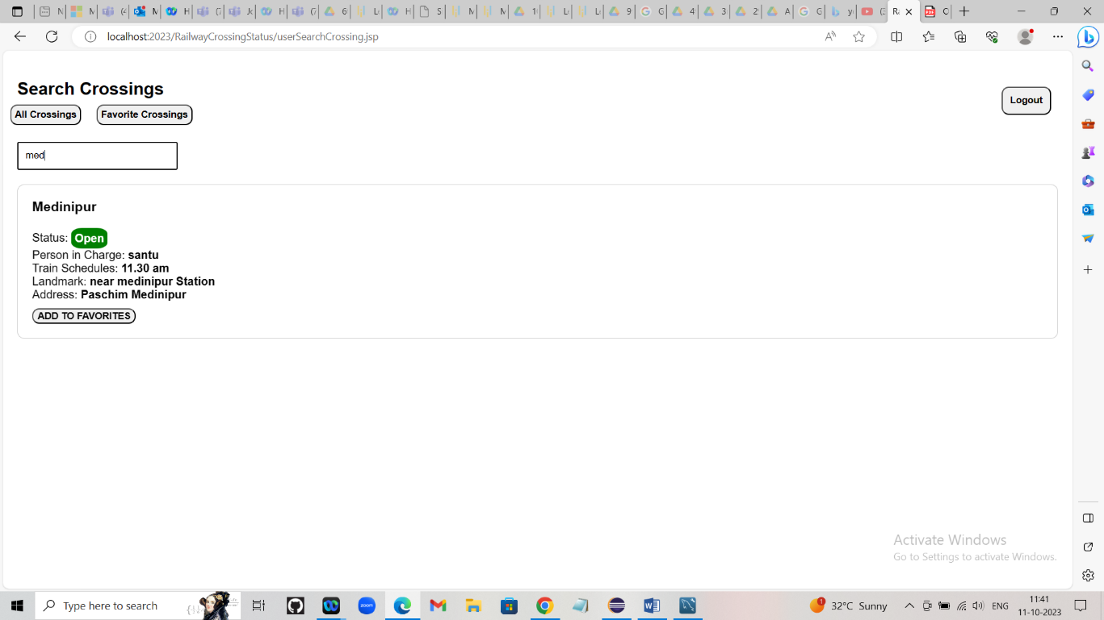



* **Logout button will redirect the user to the login oage and home button will redirect the user to home page :**

